PEZA Head Office Floor Plan with AP Location (Ground floor)
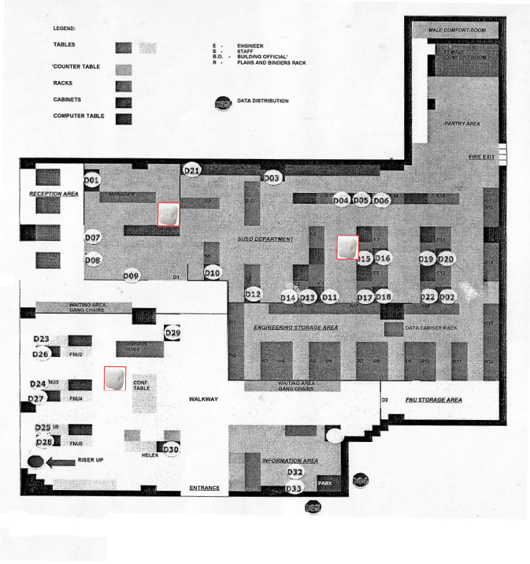

PEZA Head Office Floor Plan with AP Location (2nd floor)
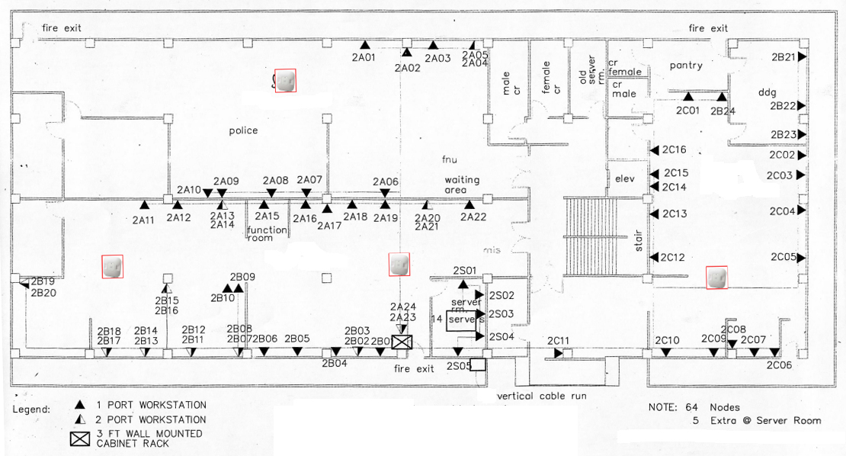

PEZA Head Office Floor Plan with AP Location (3rd floor)
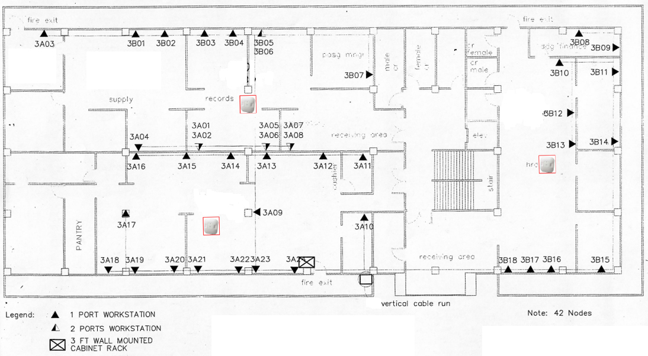

PEZA Head Office Floor Plan with AP Location (4th floor)
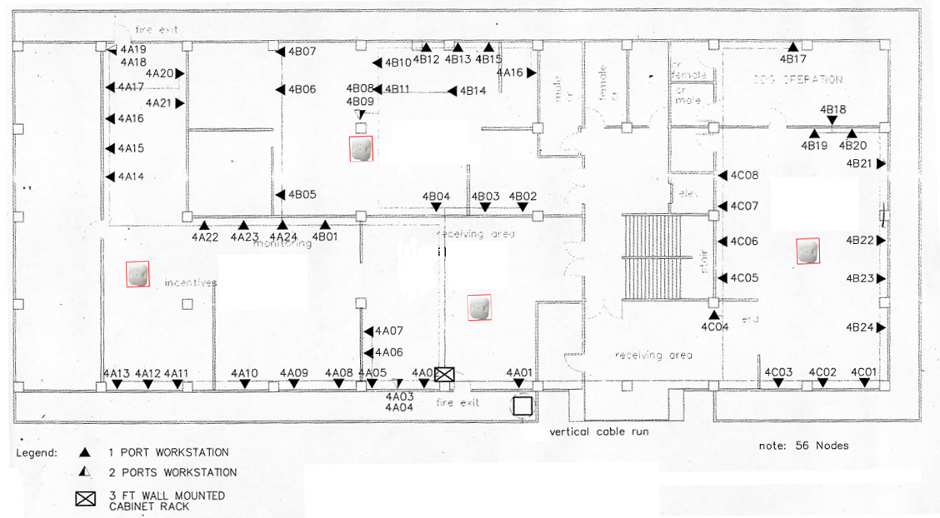

PEZA Head Office Floor Plan with AP Location (5th floor)
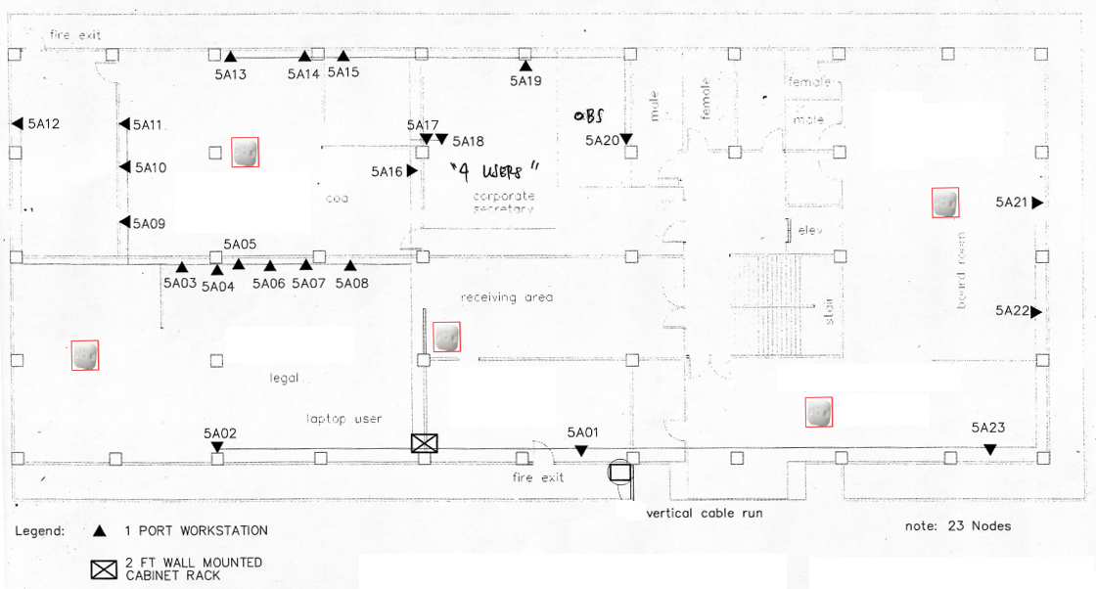

PEZA Head Office Floor Plan with AP Location (6th floor)
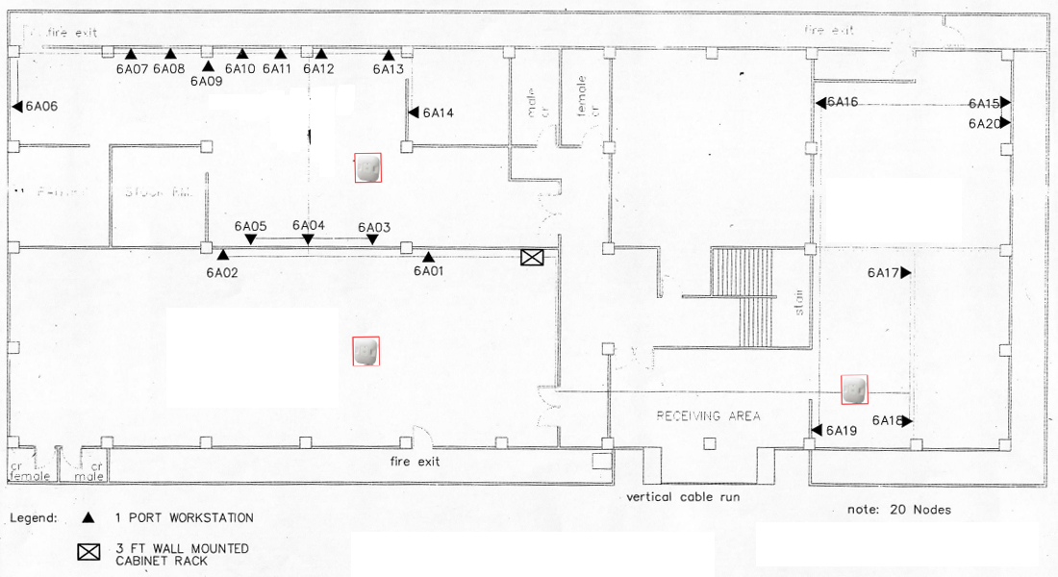

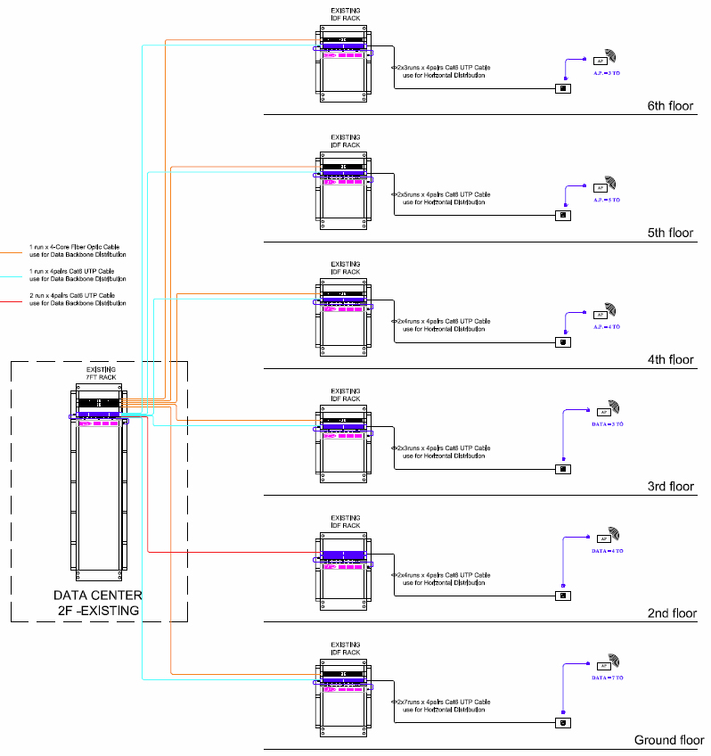
PEZA Head Office Structured Cabling

Baguio City Economic Zone Floor Plan with AP Location
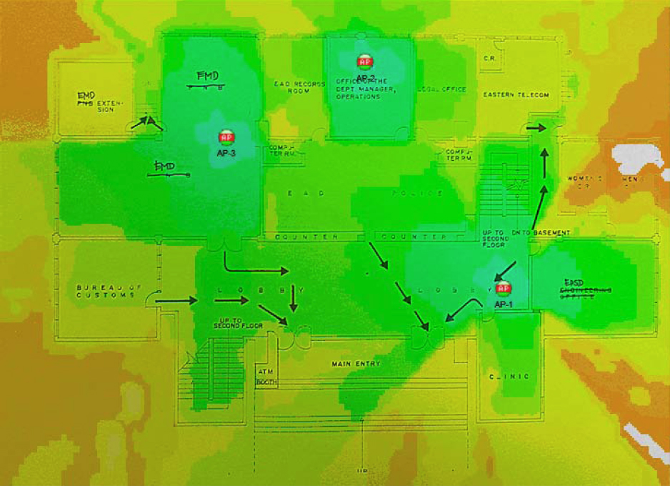

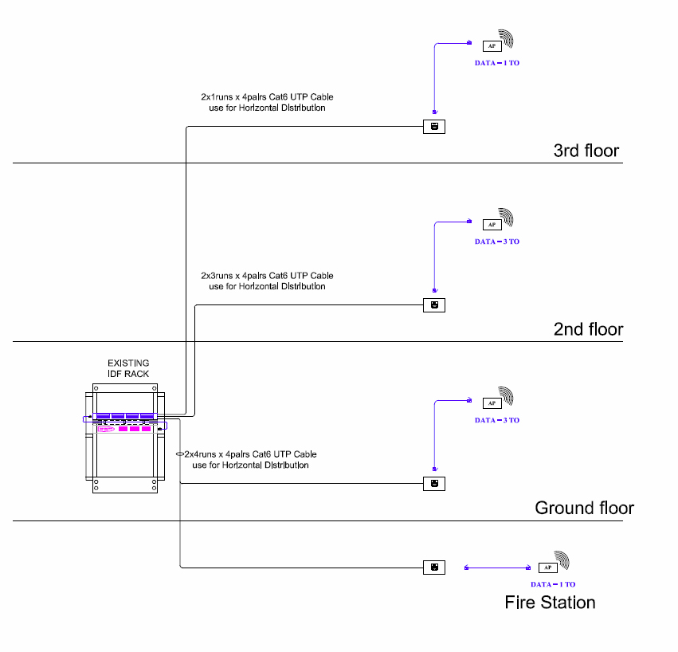
Baguio City Economic Zone Structured Cabling

Cavite Economic Zone Floor Plan with AP Location (1st floor)
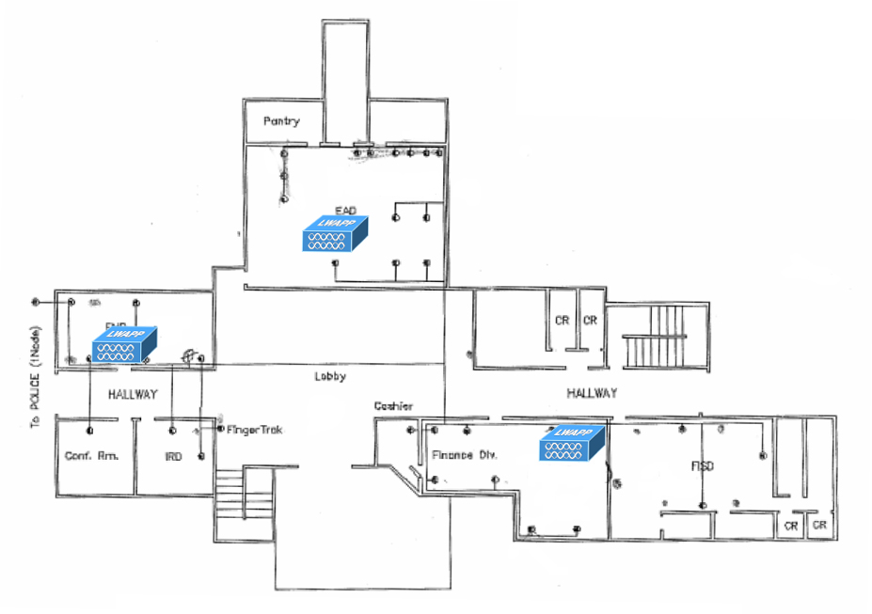

Cavite Economic Zone Floor Plan with AP Location (2nd floor)
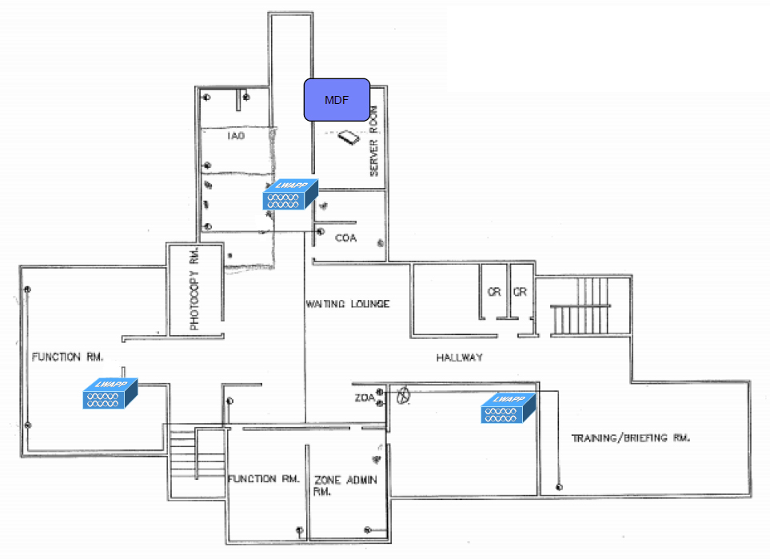

Cavite Economic Zone Structured Cabling
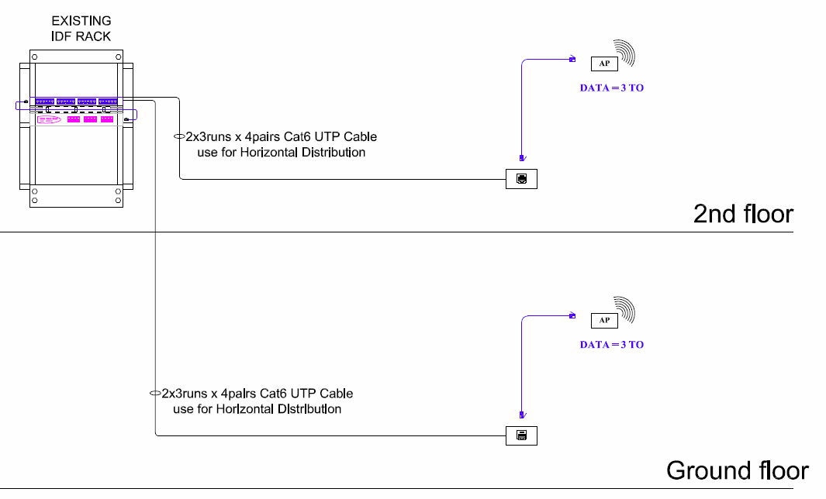

Mactan Economic Zone Floor Plan with AP Location (1st floor)
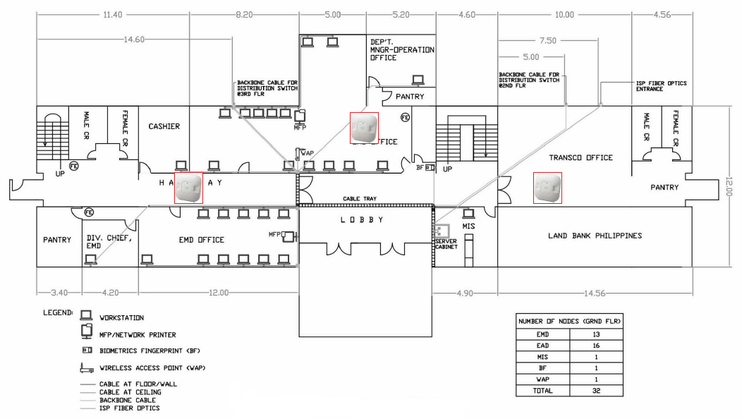

Mactan Economic Zone Floor Plan with AP Location (2nd floor)
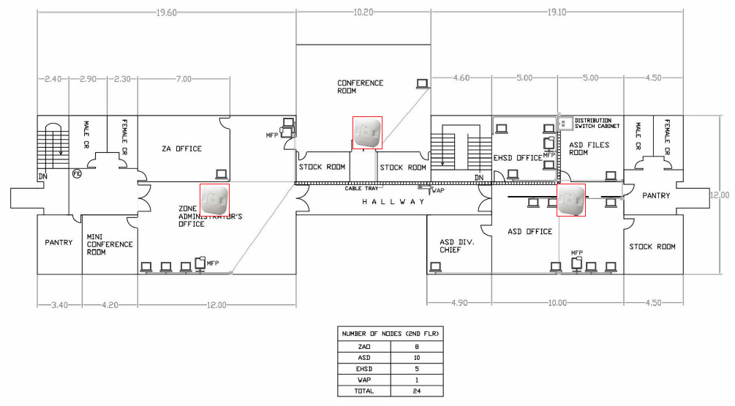

Mactan Economic Zone Floor Plan with AP Location (3rd floor)
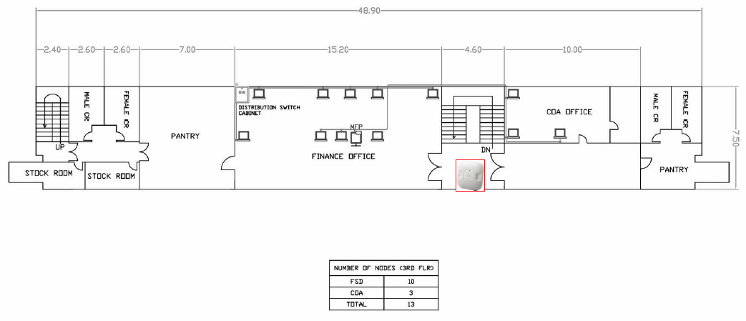

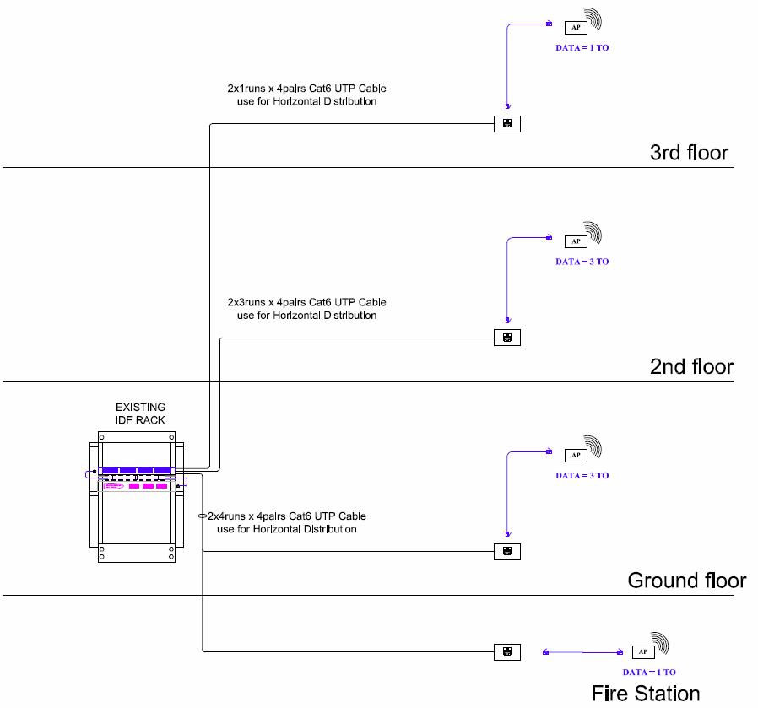
Mactan Economic Zone Structured Cabling

