Baguio City Economic Zone Floor Plan with AP Location
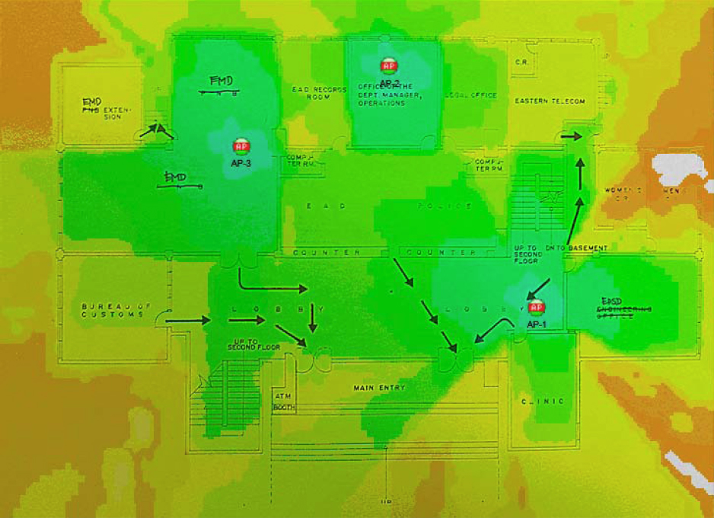

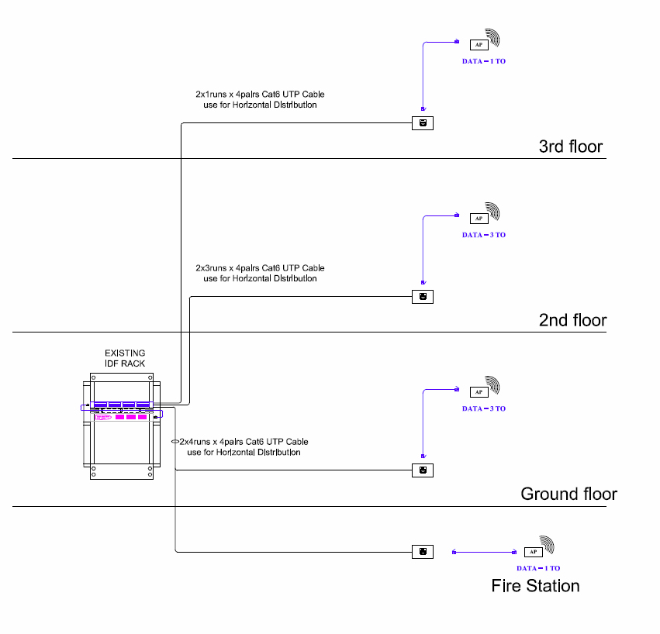
Baguio City Economic Zone Structured Cabling

Cavite Economic Zone Floor Plan with AP Location (1st floor)
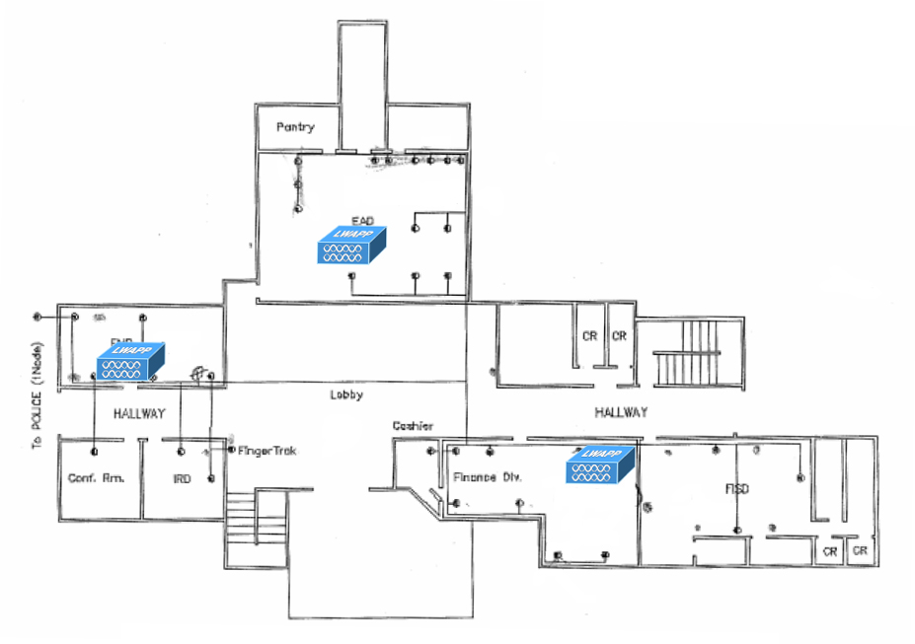

Cavite Economic Zone Floor Plan with AP Location (2nd floor)
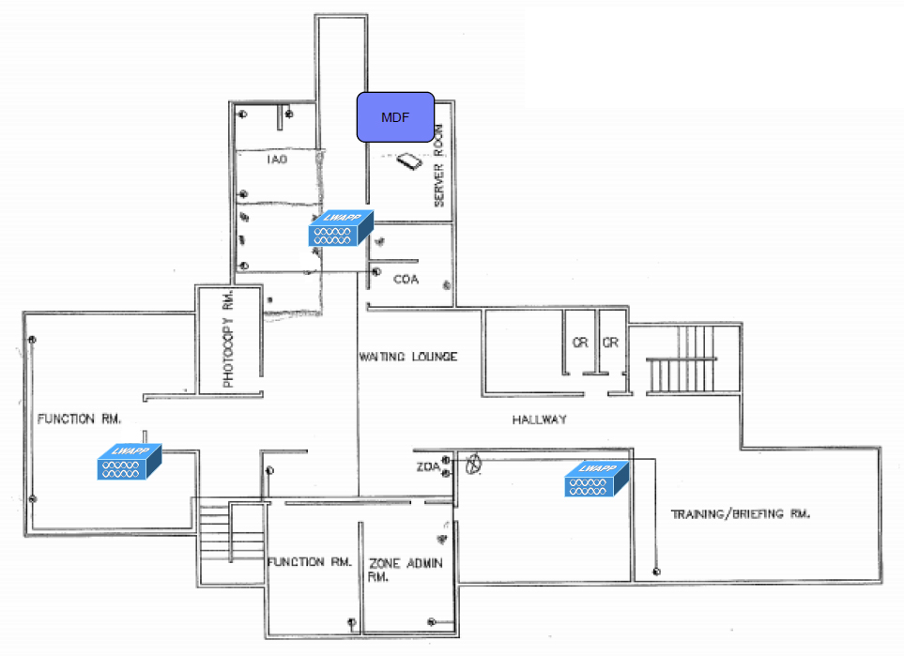

Cavite Economic Zone Structured Cabling
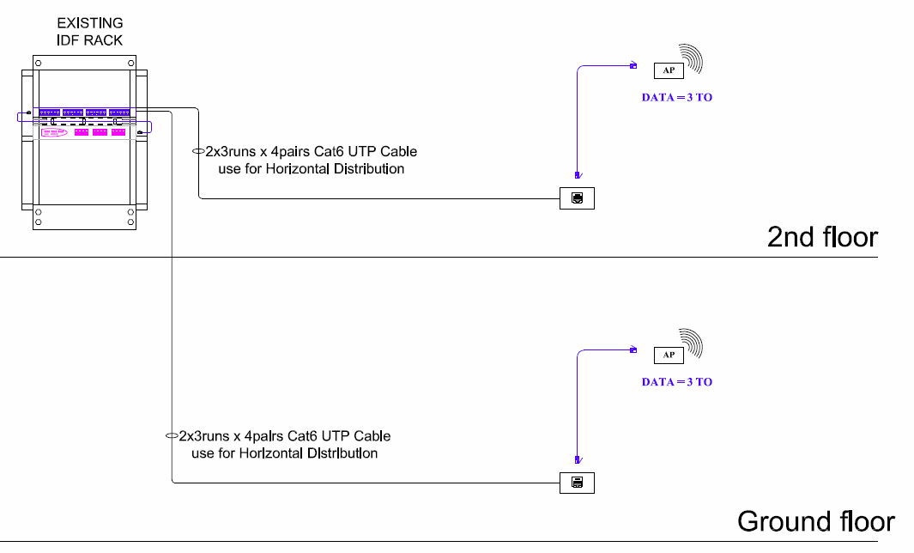

Mactan Economic Zone Floor Plan with AP Location (1st floor)
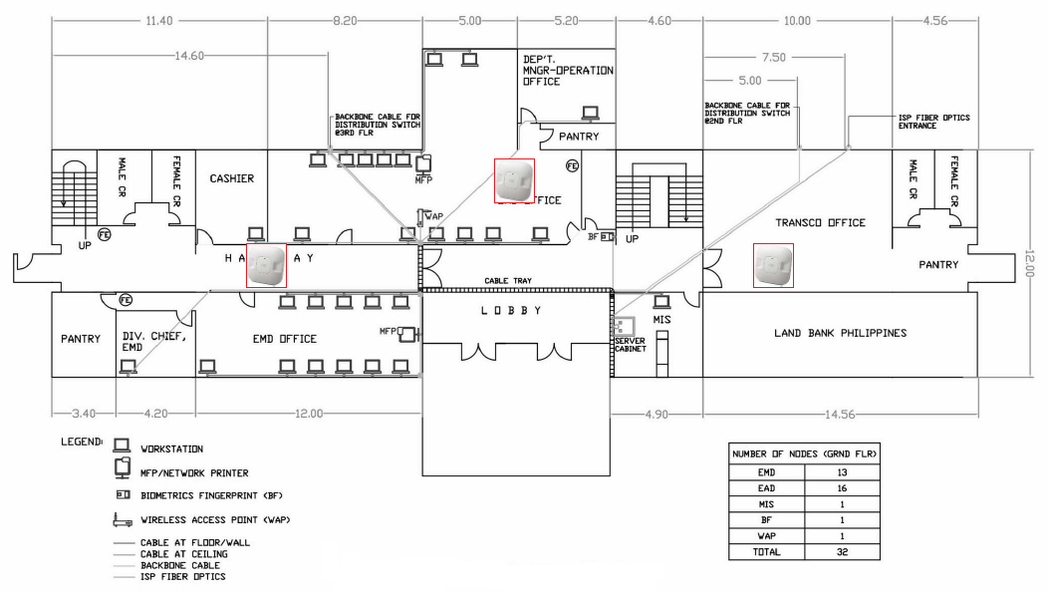

Mactan Economic Zone Floor Plan with AP Location (2nd floor)
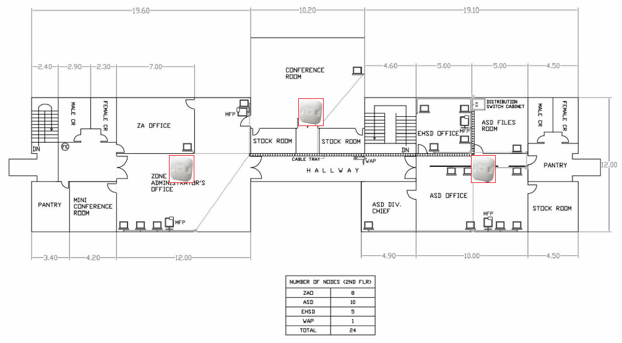

Mactan Economic Zone Floor Plan with AP Location (3rd floor)
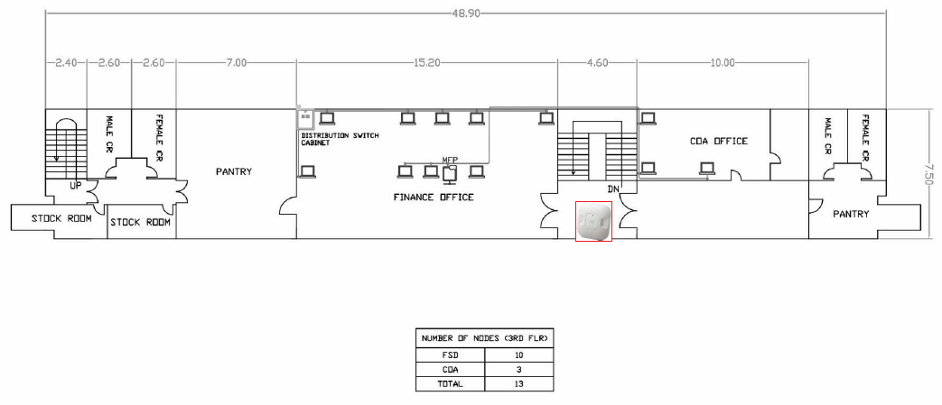

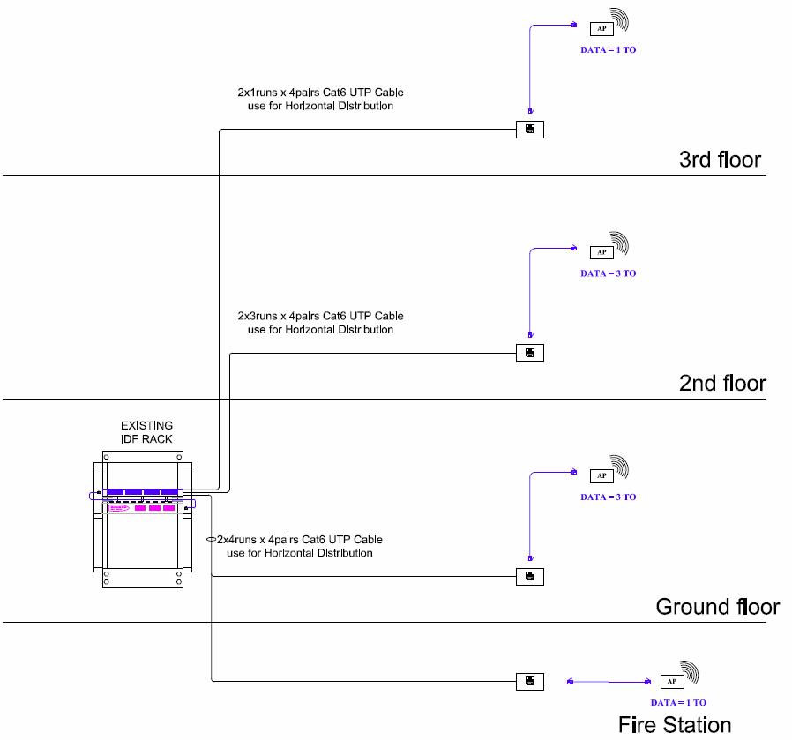
Mactan Economic Zone Structured Cabling

